Deploying resources using ARM templates
To create an ARM (Azure Resource Manager) template in Azure, you'll use JSON (JavaScript Object Notation) to define the infrastructure and resources you want to deploy. The ARM template allows you to describe the entire infrastructure as code, making it easier to create, deploy, and manage your Azure resources consistently and efficiently.

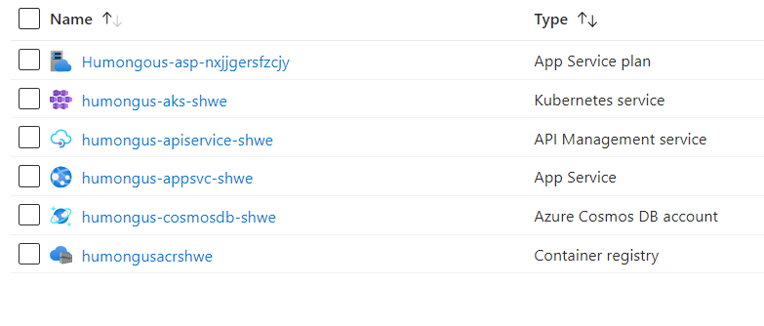

Dockerizing in task 2 so that we can push it to acr
We can add in azure api management